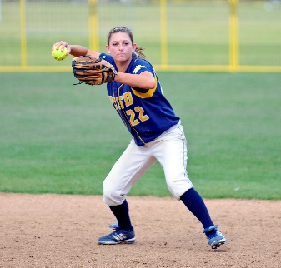

Adult Softball 2026
Team Registration
City of Beavercreek
Parks, Recreation & Culture
789 Orchard Lane, Beavercreek, OH 45434
www.beavercreekohio.gov
937-427-5514

Registration: In person or by mail with payment of cash or check. Check should be made payable to City of Beavercreek. Over the phone or on the internet with payment of credit card.
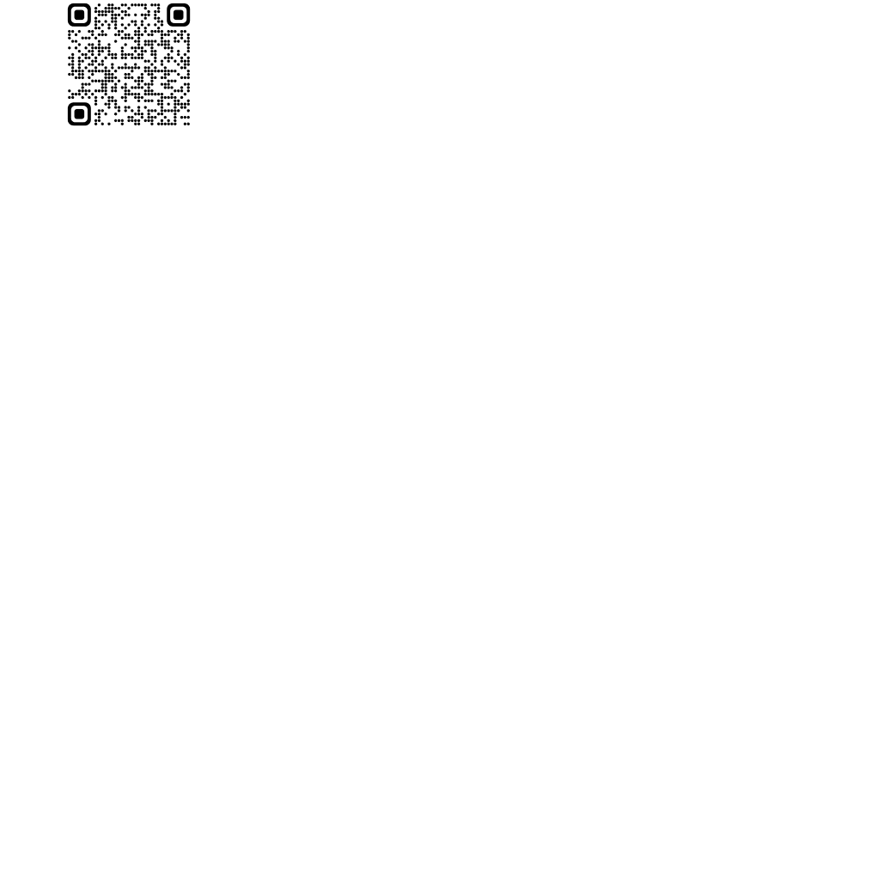
Leagues:
Day | Time | Category |  | Day |  | Time |  | Category
Monday  Monday  Tuesday  Tuesday  Tuesday * | 6:10pm  7:20pm  6:10pm  7:20pm  8:30/9:40pm | Men’s D  Men’s D  Women’s  Co-Ed  Men’s D |  | Thursday  Thursday  Friday  Friday |  | 6:10pm 7:20pm 6:10pm  7:20pm |  | Co-Ed  Co-Ed  Men’s D  Men’s D
Roster: All players must be 18 years of age or older. Players may only play on one team per league.
Sanctioning: Adult softball league sanctioned through WSL. Find out more at playwsl.com
Rules: Game play will follow WSL rules and Rotary Park rules.
Fees: League fees are due at the time of registration and include WSL sanctioning.
- $575 per team, per league
- $590 under the lights (8:30/9:40 leagues)*
- $545 each additional league with the same team name and same roster
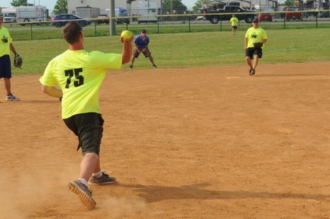
- $100 deposit will hold a spot in a league, with balance due by April 11
- Letter of intent will be accepted for those teams with a sponsor
Teams that are being sponsored by a company may submit a letter of intent to reserve a spot in their desired league. This letter must be on the company’s letterhead, with the following information listed: intended league (including night, time and category), manager’s name, address and phone number and league fee. Full payment will be due April 11.)

Season: 14 weeks beginning May 11; additional weeks for holiday and rainout makeups

Managers Meeting: WEDNESDAY, April 22 at 5:30pm VIRTUALLY (Link to join will be emailed to managers prior to the meeting)

Team Name _________________________________________ Day: M T W TH FRI
Manager’s Name ____________________________________ Time: 6:10 7:20 8:30/9:40
Address ______________________________ City __________________ Zip _____________
Cell (text alerts): _________________ Carrier _______________Email ___________________
Receipt ____________________________
Amount __________ Date _____________
**Office Use Only** Revised 1/4/2024
( ) New Team
( ) Returning Team - Same League as Last Year
( ) Returning Team - Different League from Last Year

