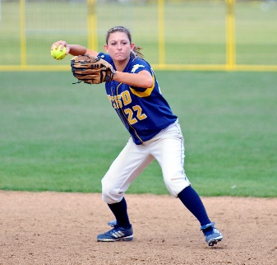**Adult Softball 2025**

**Team Registration**

City of Beavercreek

Parks, Recreation & Culture

789 Orchard Lane, Beavercreek, OH 45434

[www.beavercreekohio.gov](http://www.beavercreekohio.gov)

937-427-5514

**Registration:** In person or by mail with payment of cash or check. Check should be made payable to *City of Beavercreek.* Over the phone or on the internet with payment of credit card.

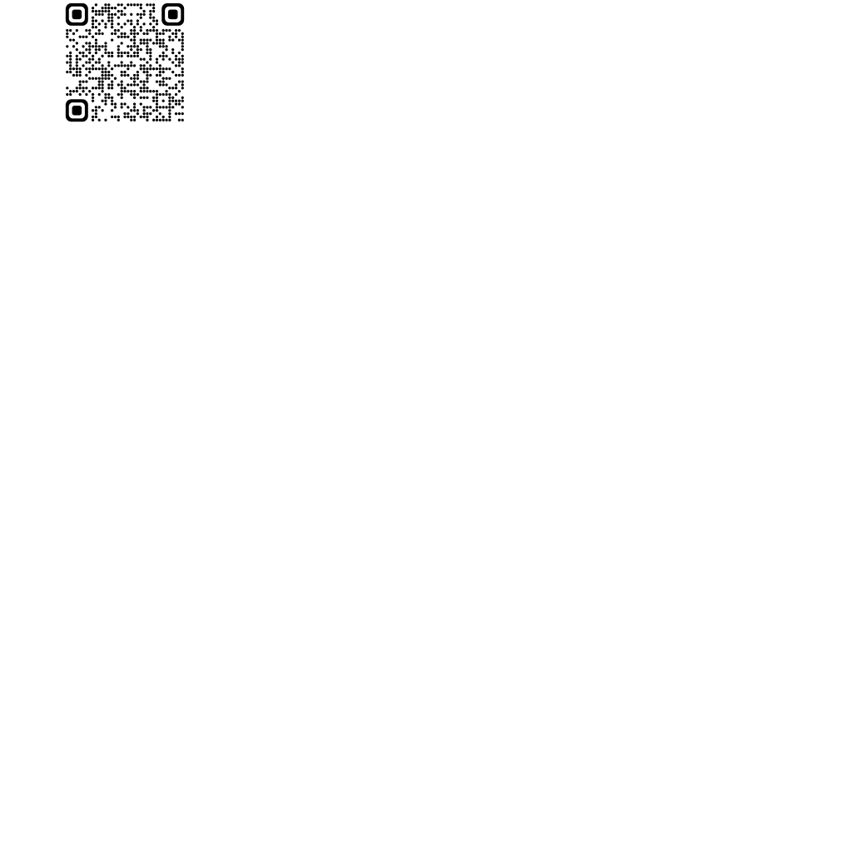

**Leagues:**

|  |  |  |  |  |  |  |  |  |  |
| --- | --- | --- | --- | --- | --- | --- | --- | --- | --- |
| **Day** | **Time** | **Category** |  | **Day** |  | **Time** |  | **Category** |  |
| Monday  Monday  Tuesday  Tuesday  Tuesday* | 6:10pm  7:20pm  6:10pm  7:20pm  8:30/9:40pm | Men’s D  Men’s D  Women’s  Co-Ed  Men’s D |  | Thursday  Thursday  Friday  Friday |  | 6:10pm 7:20pm 6:10pm  7:20pm |  | Co-Ed  Co-Ed  Men’s D  Men’s D |  |

**Roster:** All players must be 18 years of age or older. Players may only play on one team per league.

**Sanctioning:** Adult softball league sanctioned through WSL. Find out more at [playwsl.com](https://playwsl.com/)

**Rules:** Game play will follow WSL rules and Rotary Park rules.

**Fees: League fees are due at the time of registration and include WSL sanctioning.**

* $550 per team, per league
* $565 under the lights (8:30/9:40 leagues)*
* $525 each additional league with the same team name and same roster
* 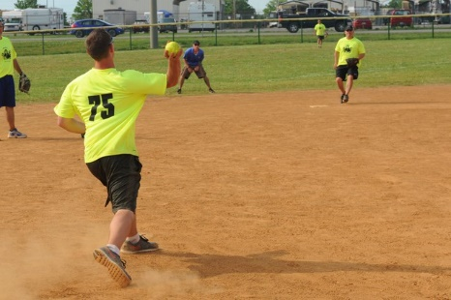$100 deposit will hold a spot in a league, with balance due by April 11
* Letter of intent will be accepted for those teams with a sponsor

*Teams that are being sponsored by a company may submit a letter of intent to reserve a spot in their desired league. This letter must be on the company’s letterhead, with the following information listed: intended league (including night, time and category), manager’s name, address and phone number and league fee. Full payment will be due April 11.)*

# Season: 14 weeks beginning May 12; additional weeks for holiday and rainout makeups

**Managers Meeting:** **TUESDAY, April 22** at **5:30pm** VIRTUALLY (Link to join will be emailed to managers prior to the meeting)

**Team Name _________________________________________ Day: M T W TH FRI**

**Manager’s Name ____________________________________ Time: 6:10 7:20 8:30/9:40**

**Address ______________________________ City __________________ Zip _____________**

**Cell (text alerts): _________________ Carrier _______________Email ___________________**

|  |
| --- |
| Receipt ____________________________  Amount __________ Date _____________  **Office Use Only** Revised 1/4/2024 |

**( ) New Team**

**( ) Returning Team - Same League as Last Year**

**( ) Returning Team - Different League from Last Year**